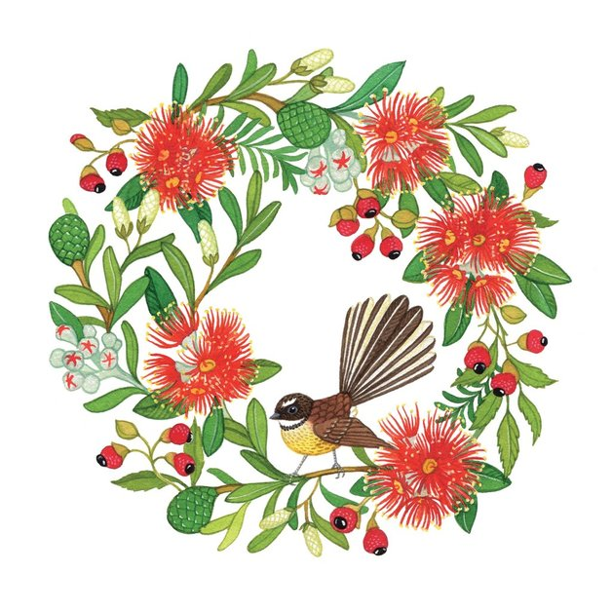



# **2024/2025 Christmas & New Year’s Season**

# **Tauranga Container Terminal & MetroPort Auckland**

The following arrangements are in place for the 2024 Christmas period.

# ***Marine Services***

The port will remain open 24 hours per day during this period and will provide piloting, tugs and linesmen for vessel movements as required. We would appreciate some flexibility in planning for the arrival of vessels if cargo is not to be worked on arrival.

For vessel arrivals or departures please contact Port Control on 07 572 8544.

# ***Tauranga Container Terminal and MetroPort*** working hours are as follows.

|  |  |  |  |  |  |
| --- | --- | --- | --- | --- | --- |
|  |  |  | **Tauranga Container Terminal** | | **MetroPort** |
|  |  |  | **Vessel Work** | **R&D** | **R&D** |
| Tuesday | 24 December |  | Until 2300 | Until 1800 | Until 1800 |
| Wednesday | 25 December |  | Closed | Closed | Closed |
| Thursday | 26 December |  | From 0600 | From 0600 | From 0600 |
|  |  |  |  |  |  |
| Tuesday | 31 December |  | Normal | Normal | Until 1400 |
| Wednesday | 1 January |  | Normal | Until 1800 | Closed |
| Thursday | 2 January |  | Normal | From 0600 | From 0600 |

**Cargo Storage**:

**TCT storage will be waived for Christmas Day.**

**MetroPort storage will be waived Christmas and New Years Day.**

For any queries regarding Terminal operating hours please refer to the numbers below:

**Tauranga Container Terminal queries: Leslie Fleming 027 807 4952**

**MetroPort queries: Alan Kirkpatrick 027 321 0027**

**Terminal Manager: Lachlan Philp 027 405 5244**

Wishing you all a Safe and Merry Christmas,

**THE TEAM AT THE PORT OF TAURANGA**